LICENSE TO CARRY (LTC)
PROFICIENCY DEMONSTRATION REQUIREMENTS
- Fire 50 rounds at B27 target (24” wide x 45” tall).
- Standing position with pistol aimed at target.
- Score a minimum of 175 out of a possible 250 points (70% required to pass), 225 points for LTC instructors (90%).
- Any rounds not fired in the allotted time, will be scored as misses.
STAGE 1 |  | 20 SHOTS | 3 YARD LINE |  |  | SCORING
A | 5 shots fired in a “one shot Exercise”, 2 seconds allowed for each shot. |  |  |  |  | 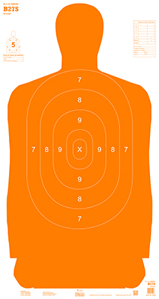  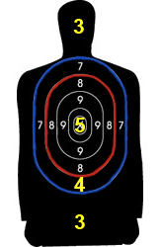
B | 10 shots fired in a “two shot exercise”, 3 seconds allowed for each two shot sequence (6 rds + 4 rds, if revolver or low mag capacity sequence will be divided).
C | 5 shots fired in 10 seconds.
STAGE 2 |  | 20 SHOTS | 7 YARD LINE
A | 5 shots will be fired in 10 seconds.
B | 5 shots will be fired in 2 sub-phases:
1 | 2 shots will be fired in 4 seconds.
2 | 3 shots will be fired in 6 seconds
C | 5 shots will be fired in “one shot exercise”, 3 seconds allowed for each shot.
D | Five shots will be fired in 15 seconds.
STAGE 3 |  | 10 SHOTS | 15 YARD LINE
A | 5 shots will be fired in 2 sub-phases:
1 | 2 shots will be fired in 6 seconds.
2 | 3 shots will be fired in 9 seconds.
B | 5 shots will be fired in 15 seconds.
TOTAL

